**Task 8**

**Output to find whether a given number is Even or Odd:**





**Output to find the Factorial of the given number:**



**Output to find whether a sum of two numbers is greater than other two numbers:**

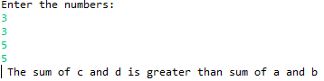

**Output to find whether a given number is Prime number or not:**





**Output to find whether a person is senior citizen or not with the age:**





**Output to display the English Alphabets:**



**Output to repeat a string “Welcome to Guvi” :**



**Output for swapping two numbers:**

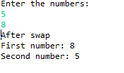

**Output to count number of digits in an integer:**



**Output to display the length of the string:**

